Invitation

The Celeritas Shooting Club as a member of the Hungarian Dynamic Sport Shooting Federation invite the below person for the Central European Open Level III Steel Challenge competition held in Felsőtárkány from 3rd to 4th September 2022.

Surname:

First name:

Address:

Passport/ID number:

Firearm(s) serial number:

Ammunition quantity:

Budapest, 2022. július 12.
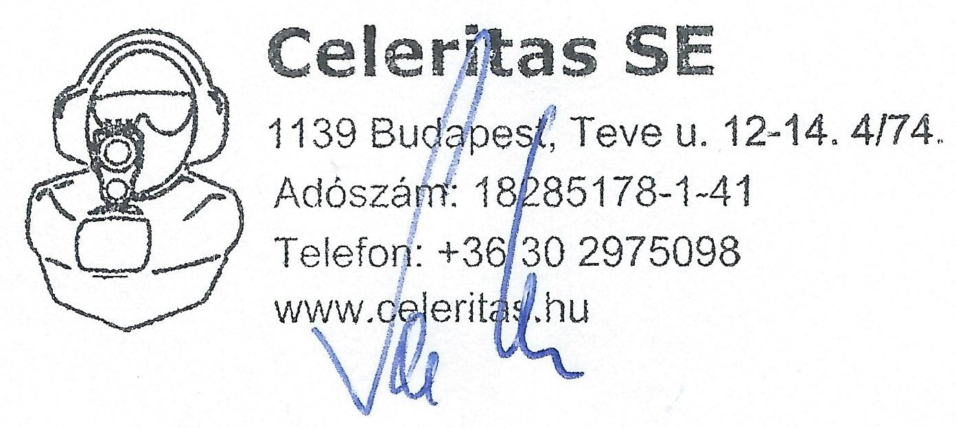

Szarvas Péter
secretary

